Referral comes in on mosaic Placement virtual tray – Assistant Manager/ Manager will allocate case.

Make sure approval for search has been agreed

-Move YP file from Live to Searching or if new into care create a file

Files should look like this

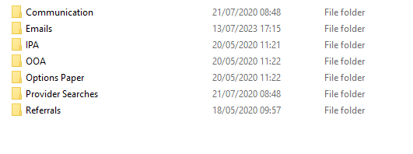

If Siblings should be one file if placed not together need single file.

-Add to live tracker

-Add to notice Tracker if needed

-Add to Admin tracker

Anonymise referral – (This is the process from exporting from mosaic to PDF)

Send referral out

* If fostering this will go to in-house first before exploring external
* Provider list for all area are on Inbox and admin folder
* Save responses in YP files on S: Drive file

Ring Round if needed ( would expect at least once a week for all cases)